3.2 Top kubectl Commands 

In this demo, we will show you how to use some of the top kubectl commands while working on any Kubernetes cluster.

* Login to your aws console
* Restart your ec2 instance and your EKS cluster nodes
* Open your terminal and SSH to the ec2 instance

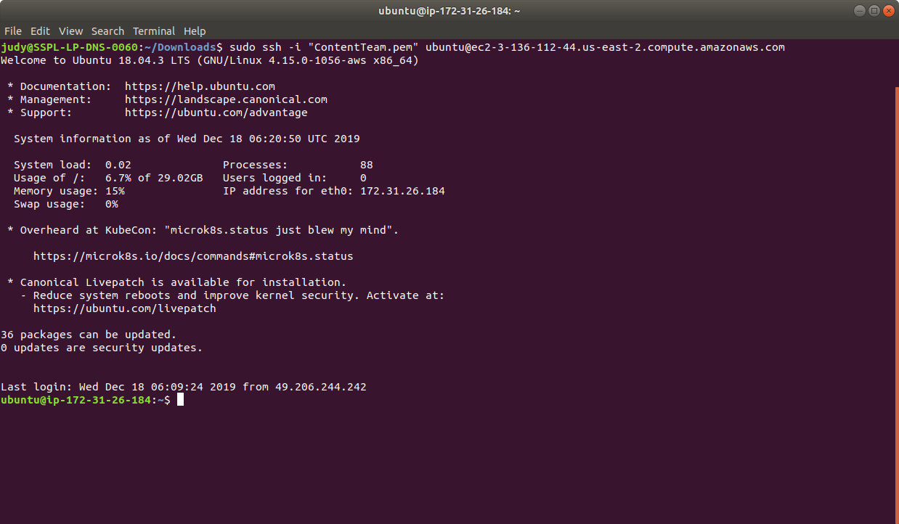

* If you don’t have an existing EKS cluster, create one with the command, **eksctl create cluster --name=myeks-cluster --nodes=2 --region=us-east-2**
* Let's now see how to use some of the common kubectl commands.
* Let us take an example of the sample yaml file named pod1.yaml as shown below:

apiVersion: v1

kind: Pod

metadata:

name: nginx

labels:

name: nginx

spec:

containers:

- name: nginx

image: nginx

ports:

- containerPort: 80

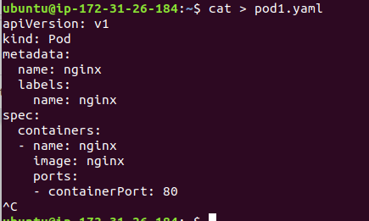

* **create** => Create a resource from a file or from stdin.

**kubectl create -f pod1.yaml**



* **get** => Display one or many resources. For example: to print pods, use kubectl get command as shown below:

**kubectl get pods**

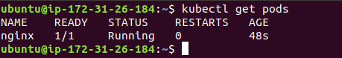

* **run** => Create and run an image, possibly replicated, as shown below:

**kubectl run nginx --image=nginx**



* **expose** => Expose a resource as a new Kubernetes service, as shown below:

**kubectl expose rc nginx --port=80 --target-port=8000**

* **delete** => Delete the resources by filenames, stdin, resources and names, or by resources and label selector, as shown below:

**kubectl delete -f pod1.yaml**

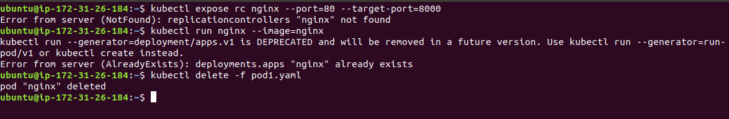

* You should now be able to use the main kubectl commands while we work with any Kubernetes cluster.